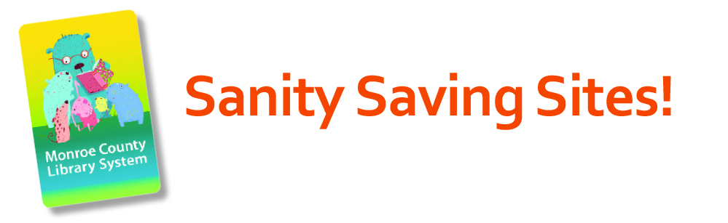

The Monroe County Library System is here for families during this difficult time. We are all trying to figure out homeschooling and life. We remain here for you! Libraries are streaming storytime and more. As the current situation evolves, more resources appear every day. Below is a list of resources to help support your family. This is not a comprehensive list. Check your child’s school website for resources supported by your school district. We will continue to add sites daily on the Central Library of Rochester & Monroe County Facebook page.
We invite you to share your sites with us. Together, we will get through this.

Books & Storytime

Monroe County Libraries have expanded content on OverDrive at https://libraryweb.overdrive.com/
Need a library card? No problem! You can get an electronic library card to gain access to our online resources: For people without library cards, they can apply for a digital card here: https://libraryweb.org/using_the_library/e-card-registration/
MyON: Free access to Renaissance myON digital reading resources for students and families during the current COVID-19 school closures. Students who are not already reading with their own personalized accounts to the myON literacy environment can log in through a single, shared account, to access this collection of curated resources.
What’s available?
• The myON digital library—which includes thousands of authentic digital books, fiction and nonfiction, covering a variety of topics and themes
• Five daily myON News articles—which are written for students by journalists and reviewed by a child psychologist for age appropriateness
These resources are available 24/7 and can be accessed on any digital device that is connected to the Internet. Books from the myON digital library can be downloaded onto mobile devices for offline reading.
How to log into myON:
1. Go to: www.myon.com and click the login button at the top of the screen
Enter the following information on the login page.School name: New York Reads
(begin typing and click on the school from the drop-down menu)
Username: read
Password: books

Day by Day - A website for young children and their families with daily ideas to keep learning fun. It is part of the New York State Library early literacy initiative Ready to Read at New York Libraries. http://daybydayny.org/

Starfall: Starfall is a publicly supported non-profit organization that creates free and low-cost online activities and resources for grades PreK to 3. The website was specifically designed to teach children to read but has since expanded to include mathematics and language arts. https://www.starfall.com/h/

Storyline Online: An award-winning children’s literacy website that features videos of celebrated actors reading from children’s books, including Viola Davis, Chris Pine, Annette Bening, James Earl Jones, Betty White, and more. Each curriculum was designed by a certified elementary educator that focuses on strengthening reading comprehension, and verbal and writing skills. https://www.storylineonline.net/library/

Storynory: This website features a vast collection of audio stories where children can read along to the text. The website’s library includes original stories, fairy tales, and classics. https://www.storynory.com/

Google Documents

Parents’ Guide to Google Classroom:
https://docs.google.com/presentation/d/1PDVZvie0DnFbFEVFB8U3j89o1mD5BCUXTE6ymbb9y_k/mobilepresent?fbclid=IwAR1kYxUp8fAvv06D704eK1wAu-FgxUdxkvb7AIYzFgeEmVv7VOySWX5TTfY&slide=id.g4f60ec15fb_1_0

Khan Academy created a suggested schedule for your kiddos to follow at home to keep a routine:
https://docs.google.com/document/d/e/2PACX-1vSZhOdEPAWjUQpqDkVAlJrFwxxZ9Sa6zGOq0CNRms6Z7DZNq-tQWS3OhuVCUbh_-P-WmksHAzbsrk9d/pub?fbclid=IwAR03xFrLXMEY-2_kOs1cRebq9l68Hn8NVaIO6BbtrFwwmHaYCPeaFRUpweI

Get out the house with free virtual field trips
https://docs.google.com/document/d/1SvIdgTx9djKO6SjyvPDsoGlkgE3iExmi3qh2KRRku_w/preview?fbclid=IwAR0HBt5_oI9ErBgw27j5N2L7hxXP7DQj79_wagT__hWVc2atzA13sCWf8jI&pru=AAABcQhO6VA*ZZQFyyFwHkp6e11LYc8ilQ

Facebook Resources
The Cincinnati Zoo will have new content daily: https://www.facebook.com/cincinnatizoo/posts/10158043843010479

Nightly Storytimes https://www.facebook.com/groups/storytimeunderground/permalink/2995966953787814/

Superhero Storytimes at 10 am
https://www.facebook.com/MightEBook/posts/2622209514735151

Instagram
Authors & Illustrators
@macbarnett will be reading a book aloud each day at 3pm ET
@oliverjeffers reading one of his books every weekday at 2pm ET
@sophieblackall on Instagram
@carsonellis leading a drawing club

Save with Stories- celebrities reading their favorite stories. https://www.instagram.com/SAVEWITHSTORIES/?utm_source=ig_embed

Netflix Educational Shows
https://homeschoolhideout.com/educational-shows-on-netflix/?fbclid=IwAR2CbxWj_9JjjYSBbR8XjfavHlzhhLliv-4lCbJ_6PuBCX67XjLkq13G7PU

YouTube

Authors Everywhere! A YouTube channel created and run by children’s books writers and illustrators. Users will find workshops, readings, activities, art projects, writing games, and writing advice that will offer fun and creative distractions during potential school closures and quarantines. https://www.youtube.com/channel/UCowhHSUaWp3KJDcuI0nR0vw?view_as=subscriber

Jarrett J. Krosoczka—author & illustrator: New York Times-bestselling author and illustrator Jarrett J. Krosoczka offers an expansive list of tutorials, activities, webcasts, etc. on his YouTube channel. https://www.youtube.com/user/studiojjk/videos

Lunch Doodles with Mo Willems
kennedycenter.org/mowillems 1pm Weekdays
https://www.youtube.com/watch?v=MjaYnyCJDdU&feature=youtu.be&fbclid=IwAR3qP2_rjPpcMeMfVRxuaTbJmqgJmiPZRdVjIla61VNoR8_B2NZoDnXeWNE

Science Mom
https://www.youtube.com/channel/UC-QcZISbFb9EiIEQ41cVhxw?fbclid=IwAR0n4Tjy70OdEfq3PRdUn0H0bmIwZLkNf3k5FmQgL0Kh1CCrRldpOPxL1_8

Writing Workshop Jen Calonita Author
The first writing challenge is up! And it comes with a prize. Every kid who tackles one of this week’s writing prompts and has a parent comment on this page that they’ve tried the assignment (or you want to send a screenshot of their work) will be entered to win an autographed copy of VIP. Each week I’ll pick a new book to give away and I’ll pick a winner at random on Sunday (U.S. only). Have fun! https://youtu.be/NsMEvnjpWZY

Jarrett J. Krosoczka Drawing Studio
2pm Weekdays
https://www.youtube.com/user/studiojjk

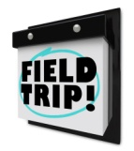More Virtual Field Trips

https://www.parents.com/syndication/museums-with-virtual-tours/?utm_campaign=parents_parentsmagazine&utm_content=internalsyndication_travelandleisure&utm_source=facebook.com&utm_term=FD51F848-6550-11EA-9FBA-CF782FEB5590&utm_medium=social&fbclid=IwAR0b-8pUdJdk3gKzwWzCeUXAYBKuIIitB9IfSLgv-raAqvZf-o_Sy_C8UmM

National Parks https://totallythebomb.com/heres-33-national-park-tours-you-can-take-virtually-from-the-comfort-of-your-home?fbclid=IwAR2U0jo3yS772MSkn6p1dIDV5pRQQsch1OblxEGOKUoiNfhtXx74wjW66uk

Podcast for Kids

Button & Figs: A fun, educational program for kids, parents, educators, librarians, anyone, everyone who values wordplay. Buttons & Figs introduces kids to great nonsense literature, poetry, and songs as a way to give them permission to play with words. Created by 2 librarians and Arizona school agers, this imaginative podcast is inspired by great works of fiction and poetry! http://buttonsandfigs.com/

Eleanor Amplified- A podcast from WHYY Philadelphia. An old-school styled radio show with a snappy modern heroine. Follow Eleanor's adventures as she stops the bad guys and reports the news. Fun for the whole family, recommended for ages 8-12. https://whyy.org/programs/eleanor-amplified/
Storynory - Free stories for kids age 7 to 11 including some fun re-tellings of classical myths and lots of original content. https://www.storynory.com/
Tumble - A science podcast for kids and grownups. Listen to stories about science discoveries with the help of scientists! http://www.sciencepodcastforkids.com/

